Degradation of 17α-ethinylestradiol in water through heterogeneous photocatalysis

ABSTRACT

The aim of the study was to investigate the degradation of 17α-ethynylestradiol in aqueous solution using a batch heterogeneous photocatalytic (HPC) reactor with ultraviolet (UV) light and TiO₂ catalyst. In order to determine appropriate operating conditions, a 2³ factorial experiment was conducted with initial substrate concentration of 15 or 30 mg.L⁻¹, TiO₂ concentration of 0.02 or 0.05%, pH of 5.0 or 9.0 and total reaction time 240 min. Degradation profiles and kinetic parameters were determined with initial substrate concentration of 15 or 30 mg.L⁻¹, 0.02% TiO₂ and pH 7.0.With17α-ethynylestradiol at 15 mg.L⁻¹, degradation efficiency was 100% after 120 min independent of TiO₂ concentration and pH. However, less than 50% of substrate was degraded when the initial concentration was 30 mg.L⁻¹ (0.05% TiO₂ and pH 5.0). Initial substrate concentration was a limiting factor for HPC, although the reaction was also strongly influenced by TiO₂ concentration and the interaction between initial substrate concentration and TiO₂ concentration. All degradations followed first-order kinetics. With 17α-ethynylestradiol at 15 mg.L⁻¹, the half-life time (t_{½}) was 64.16 min and the rate constant was 0.108 min⁻¹, while at 30 mg.L⁻¹, substrate degradation proceeded in two stages, the t_{½} values of which were 44.71 and 433.12 min.

KEYWORDS: endocrine disrupters, reaction kinetic, water treatment

DEGRADAÇÃO DE 17Α-ETINILESTRADIOL EM ÁGUA ATRAVÉS DE FOTOCATÁLISE HETEROGÊNEA

RESUMO

O objetivo desse trabalho foi investigar a degradação de 17α-etinilestradiol em solução aquosa usando um reator fotocatalítico heterogêneo em batelada com radiação ultravioleta e TiO₂ como catalisador. Com a finalidade de obter as condições ideais, um planejamento fatorial 2³ foi realizado com concentração inicial de 15 e 30 mg.L⁻¹, concentração de TiO₂ de 0.02 e 0.05%, variou-se o pH em 5.0 e 9.0 e tempo total de reação de 240 min. O perfil da degradação e parâmetros cinéticos foram determinados com concentração inicial de 15 e 30 mg.L⁻¹, 0.02% de TiO₂ e pH 7.0. Com concentração inicial de 15 mg.L⁻¹ de 17α-etinilestradiol a eficiência de degradação foi 100% após 120 min independente da concentração de TiO₂ e pH. Contudo menos que 50% do substrato foi degradado quando a concentração inicial utilizada era de 30 mg.L⁻¹ (0.05% TiO₂ e pH 5.0). A concentração inicial do substrato foi um fator limitante para a fotocatálise heterogênea. A reação também foi fortemente influenciada pela concentração de TiO₂. Todas as degradações seguiram cinética de primeira ordem. Para concentração de 17α-etinilestradiol de 15 mg.L⁻¹, o tempo de meia vida (t_{½}) foi 64.16 min e a constante cinética foi 0.108 min⁻¹, enquanto para a concentração de 30 mg.L⁻¹, a degradação do poluente aconteceu em dois estágios, com valor de t_{½} de 44.71 e 433.12 min.

PALAVRAS-CHAVE: disruptores endócrinos, ?????????, tratamento de água

1. INTRODUCTION

Pharmaceuticals, persistent organic pollutants (POP) and endocrine disrupters (ED) are frequently found in effluents and surface water and on various solid matrices such as soils and sediments. The synthetic oestrogen 17α-ethynylestradiol (C₂₀H₂₄O₂), which is used as an oral contraceptive and in treating the symptoms of menopause and the prevention of abortion (Ghiselli and Jardim, 2007), is one of the major contributors to ED activity in the effluent from water treatment plants (Johnson and Sumpter, 2001). Although the Brazilian Ministry of Health has established standards for drinking water (Ministério da Saúde do Brasil, 2011), the majority of ED drugs are not listed in the resolution and, therefore, water treatment plants do not test for them. However several published articles have shown that such compounds are not removed completely by the conventional processes employedin water and sewage treatment plants (Bila and Dezotti, 2007; Pereira et al, 2011).

Advanced oxidation processes (AOP) are based on the generation of reactive hydroxyl radicals (OH•) with strong oxidant power (Eº = 2.8 V) that are capable of mineralizing POP to non-toxic CO₂ and H₂O. AOP offer operational simplicity and high efficiency in the oxidation of a vast array of substances (Taffarel et al, 2011), and can be applied as alternative procedures or in combination with conventional methods (Konstantinou and Albanis, 2003; Ferreira and Daniel, 2004). Among the various AOP strategies that have been described, heterogeneous photocatalysis (HPC), induced by radiation and performed with the help of a semiconductor, has received considerable attention because of its high efficiency in removing organic pollutants from drinking water and effluents.

In this context, the aims of the present study were (i) to investigate the degradation of 17α-ethynylestradiol in a batch HPC reactor under ultraviolet (UV) light and TiO₂ as catalyst, and (ii) to verify the influence of the initial concentration of substrate on the kinetics of the reaction.

2. MATERIALS AND METHODS

Solvents and reagents. The water used in the experiments was supplied by the Estação Experimental de Tratamento Biológico de Esgotos Sanitários (EXTRABES, Campina Grande, PB, Brazil). The 17α-ethynylestradiol (CAS 57-63-6; 98% purity; Sigma-Aldrich, St. Louis, MO, USA) was firstly dissolved in methanol (Index-No 603-001-00-X; purity > 99,9%; Merck, Darmstadt, German), then a stock solution containing 100 mg.L⁻¹ was prepared in water under constant agitation and storage in refrigerator at 4ºC. Working solutions were obtained by diluting an aliquot of the stock solution with an appropriate volume of water and adjusting the pH with 1M HCl or 1M NaOH as required. TiO₂ (98.5% purity; 0.5% loss on drying; Labsynth, Diadema, SP, Brazil) was used as catalyst.

Photocatalytic reactor. The reactor comprised a wooden chamber (1 m long x 0.60 m wide x 0.65 m high) equipped with eight UV lamps (254 nm wave length; 15 W) and an orbital shaker (Orbital TE 141, Tecnal) with capacity for 12 x 100 mL Erlenmeyer flasks. The distance between the surface of the solutions and the lamps was 0.25 m, and the total light intensity was 7.46 mW.cm⁻²

Experiment I- Operating conditions.In order to establish appropriateoperating conditionsfor the degradation of 17α-ethynylestradiol, assays were conducted according to a 2³ factorial designusingthe conditions shown in Table 1. Each assay was conducted in triplicate to give a total of 24 assays. Flasks containing the assay solutions (100 mL) were placed inside the HPC reactor, the catalyst was added in the absence of UV light, and the reaction mixtures were agitated for a few minutes. The UV lamps were then switched on and the residence time set to 240 min. In order to determine the percentage of substrate degraded, samples of the reaction suspensions were removed at 0 min (T₀) and 240 min (T₂₄₀), centrifuged for 15 min at 3600 rpm (Baby^{R} I centrifuge, model 206, FANEM São Paulo Brazil), and the supernatants analysed according to the method of Teixeira and Teixeira (2006). Statistical analyses of the data were performed with the aid of Minitab 14 software in order to detect the individual and paired effects of the reaction parameters: differences were considered statistically significant at p = 0.05.

Table1. Parameters and levels of the 2³ factorial experiment.
Treatment | Codified |  |  | Numerical
 | X₁ | X₂ | X₃ | X₁ | X₂ | X₃
T₁ | - | - | + | 5.0 | 0.02 | 30
T₂ | + | - | + | 9.0 | 0.02 | 30
T₃ | - | + | + | 5.0 | 0.05 | 30
T₄ | + | + | + | 9.0 | 0.05 | 30
T₅ | - | - | - | 5.0 | 0.02 | 15
T₆ | + | - | - | 9.0 | 0.02 | 15
T₇ | - | + | - | 5.0 | 0.05 | 15
T₈ | + | + | - | 9.0 | 0.05 | 15
X₁=pH; X₂=Percentage of catalyst TiO₂ (%); X₃=Initial concentration of substrate (mg.L⁻¹).

Experiment II – Degradation time and kinetics. Based on the results obtained in Experiment I, the profile and kinetics of the degradation of 17α-ethynylestradiol were examined by conducting assays under the following conditions: initial concentration of substrate, 15 or 30 mg.L⁻¹; concentration ofTiO₂, 0.02%; pH of reaction mixture, 7.0. HPC was conducted as described above and sampling of the reaction suspensions was performed every 10 min from T₀ to T₃₀, then every 15 min to T₉₀ and then every 30 min to T₂₄₀. In each case, the concentration of substrate remaining in the sample was determined as described above. The degradation rate constant was calculated according to the first-order rate equation:

ln C_{t}/C₀= kt_{1/2} (1)

in which C₀ and C_{t} are the concentrations of substrate (mg.L⁻¹) at T₀ and T₂₄₀, respectively, k is the rate constant (min⁻¹) and t_{1/2} is the reaction half-life (min).

3. RESULTS AND DISCUSSION

Experiment I – Influence of reaction parameters. Table 2 shows the amount of 17α-ethynylestradiol (mg.L⁻¹) removed from the reaction mixtures and the percentage degradation following 240 min reaction. Degradation of substrate was achieved under all operating conditions, and the mean efficiency was 81%. It was not determined whether by-products were formed or if the estrogenic activity of the reaction mixture was reduced. The most efficient degradation (100%) was obtained under operating conditions T5 to T8, while the least appropriate condition was T3, under which a degradation efficiency of less than 50% was obtained. It is noteworthy that 100% degradation was attained when ever the initial concentration of 17α-ethynylestradiol was 15 mg.L⁻¹, independent of the amount of catalyst present or the pH of the reaction mixture. When the initial substrate concentration was increased to 30 mg.L⁻¹, the degradation efficiency diminished considerably. This effect may be attributed to the substrate absorbing more radiation than the catalyst, as previously suggested by Kashif and Ouyang (2009) following studies involving the photodegradation of phenol in the presence of UV light and TiO₂.

Table2. Degradation of 17α-ethynylestradiol following 240 min of heterogeneous photocatalysis.
Treatment | pH | TiO₂  (%) | C_{i}ª  (mg.L⁻¹) | C_{f}^{b}  (mg.L⁻¹) | Substrate Removed  (mg.L⁻¹) | Substrate Degraded  (%)
T₁ | 5.0 | 0.02 | 30 | 8.66 | 21.33 | 71.13
T₂ | 9.0 | 0.02 | 30 | 7.40 | 22.60 | 75.30
T₃ | 5.0 | 0.05 | 30 | 15.12 | 14.90 | 49.60
T₄ | 9.0 | 0.05 | 30 | 14.30 | 15.71 | 52.35
T₅ | 5.0 | 0.02 | 15 | 0 | 15.00 | 100
T₆ | 9.0 | 0.02 | 15 | 0 | 15.00 | 100
T₇ | 5.0 | 0.05 | 15 | 0 | 15.00 | 100
T₈ | 9.0 | 0.05 | 15 | 0 | 15.00 | 100
ª initial concentration of substrate; ^{b} final concentration of substrate

Experiment I – Statistical analysis. The Pareto diagram presented in Figure 1 shows the individual and paired effects of the reaction parameters on the degradation of 17α-ethynylestradiol. The bars represent the magnitude of the effects, while the transversal line corresponds to the p value of 2.12 and reveals the effects that were statistically significant at an alpha level of 0.05.

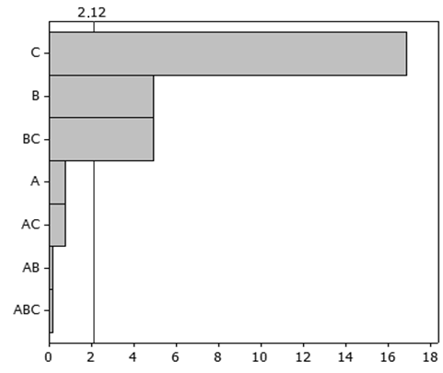

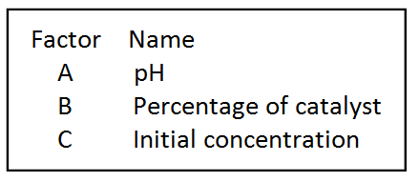

Figure 1. Pareto diagram showing the magnitude of the effects of the reaction parameters (A, pH; B, TiO₂ concentration; C, initial concentration of 17α-ethynylestradiol) on the degradation of17α-ethynylestradiol (p = 0,05).

The most important parameters for HPC degradation were, in decreasing order, C (initial concentration of 17α-ethynylestradiol) > B (TiO₂ concentration) > BC (interaction between the initial concentration of substrate and the concentration of TiO₂). According to Dallago et al. (2009), pH is very important during the adsorptive phase, which is the rate-limiting step in the degradation process, since particles of TiO₂may agglomerate in acidic solution and consequently reduce the surface area for adsorption of substrate and absorption of photons. However, while pH may negatively influence the adsorptive phase of HPC, neither this factor alone, nor its interaction with other parameters, exerted a significant effect on the degradation of 17α-ethynylestradiol.These findings contrast with the results of Gálvez et al. (2001), which revealeda strong influence of pH on photocatalysis. These authors state that pH not only modifies the surface properties of the catalyst and the chemical form of the substrate, but also promotes the flocculation of the catalyst. In the present study, 17α-ethynylestradiolat an initial concentration of 15 mg.L⁻¹was degraded efficiently at both pH 5 and pH 9. However, at the higher substrate concentration, pH exerted a stronger influence when theTiO₂ concentration was high (0.05%), hence it was not possible to draw any conclusions regarding the influence of pH on the photodegradation of 17α-ethynylestradiol. Similarly, Liu et al. (2003) could not evaluate the influence of pH in their experiments involving the degradation of 17α-ethynylestradiol in aqueous solutions.

The results presented herein demonstrate that the interaction between TiO₂ concentration and the initial concentration of substrate exerts a strong effect on degradation efficiency, being greater at the lower values tested (i.e. 0.2% and 15 mg.L⁻¹, respectively). Evidently, a high concentration of catalyst provides a larger number of irradiated particles thereby increasing the rate of generation of free electrons up to a threshold level. Méndez-Arriaga et al. (2008) observed that the turbidity of the reaction mixture in the presence of excess catalyst reduced the infiltration of radiation, while Chiou et al. (2008) reported that excess catalyst diminished light penetration and, consequently, reduced the photodegradation of phenol. Another possible cause of reduced photodegradation efficiency in the presence of excess catalyst is the deactivation of active molecules through collision with ground-state molecules (Zhang et al., 2007). Zhang and Zhou (2005) have also stated that UV-induced photodegradationdoes not depend on the initial concentration of substrate, suggesting the potential of process applications involving various types of matrices. Moreover, the authors emphasized the value of this method for the degradation of different organic pollutants, possibly involving the use of immobilized catalysts as a way of avoiding their removal at the end of the reaction.

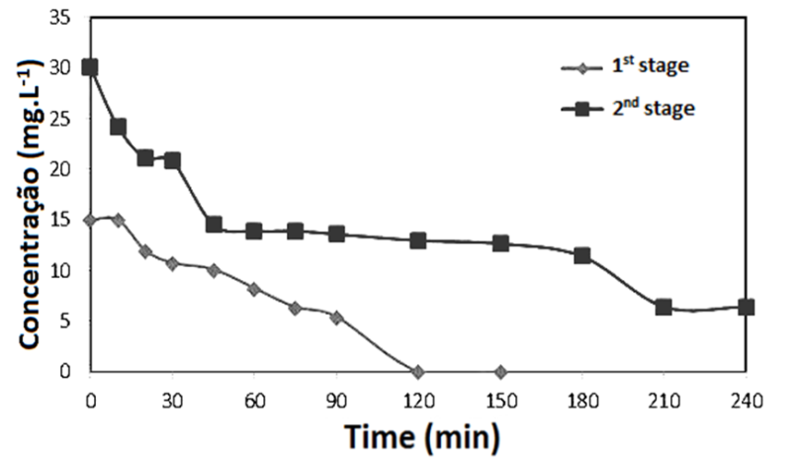

Figure 2. Degradation profiles of 17α-ethynylestradiol at initial concentrations of 15mg.L⁻¹() and 30mg.L⁻¹() in the presence of UV light and 0.02% TiO₂ (pH 7.0).

Experiment II–Profile of degradation reaction. Figure 2 shows the progress of 17α-ethynylestradiol degradation as a function of time, and confirms that the efficiency of HPC was much higher (100% degradation in 120 min) when the initial concentration of substrate was 15 mg.L⁻¹. At the higher substrate concentration (30 mg.L⁻¹), degradation remained incomplete even after 240 min of reaction.

Experiment II–Kinetics of degradation reaction. The photocatalytic degradation of organic compounds typically follows first-order kinetics. However, the rate of reaction varies with the complexity of degradation, the amount of substrate adsorbed onto the surface of the catalyst, and the absorption spectra of the substrate. When substrateswith high UV absorption coefficients are used in excess, they cover the surface of the catalyst and impede the penetration of radiation. In the present study, when the initial concentration of 17α-ethynylestradiol was15mg.L⁻¹, the degradation process was rapid (90 min; Figure 3A): at the higher concentration of substrate, however, photocatalysis occurred in two distinct stages, the second of which was very much slower (Figure 3B).

The kinetic parameters for the photodegradation of 17α-ethynylestradiol are presented in Table 3. The reaction followed first-order kinetics regardless of the initial concentration of substrate employed. At an initial concentration of 17α-ethynylestradiol of 15 mg.L⁻¹, 50% of the substrate was degraded in approximately 60 min. However, when the initial concentration was 30 mg.L⁻¹, two degradation stages were required in order to reduce the level of substrate from 30 to 7.5 mg.L⁻¹. The first stage involved a reaction with a t_{½}of less than 45 min, while that of the second stage was 433.12 min. Lau et al. (2005) reported similar results following a study of the photodegradation of di-n butyl phthalate except that, in this case, pH exerted a strong influence on the reaction kinetics. In the present study, the degradations were carried out at the fixed pH of 7.0 and, therefore, it was not possible to draw any conclusions regarding the significance of this parameter on the performance of HPC.

Table 3.Kinetic parameters of the photodegradation of 17α-ethynylestradiol.
C_{i}ª(mg.L⁻¹) | Stage | k^{b}(min⁻¹) | R^{2c} | t_{½} ^{d}(min)
15 | 1 | 0. 0108 | 0. 9861 | 64.16
30 | 1 | 0.0155 | 0. 9716 | 44.71
30 | 2 | 0. 0016 | 0. 9733 | 433.12
ª Initial concentration of substance; ^{b}rate constant; ^{c}linear correlation coefficient; ^{d} half-life time

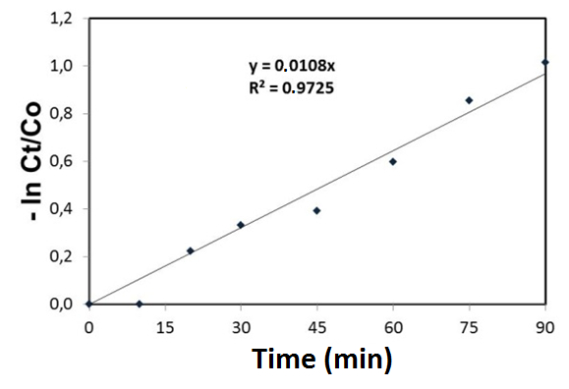

A

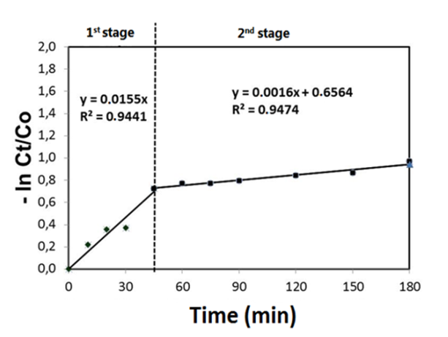

B

Figure 3. Rates of degradation of 17α-ethynylestradiol at initial concentrations of (A) 15mg.L⁻¹and (B) 30mg.L⁻¹ in the presence of UV light and 0.02% TiO₂ (pH 7.0) (p=0,05).

4. CONCLUSIONS

Experiment I showed that degradation of 17α-ethynylestradiol using a HPC system was very efficient (mean value 81%). When the initial concentration of 17α-ethynylestradiol was 15 mg.L⁻¹, the degradation efficiency was 100% after 120 min of reaction, independent of the TiO₂ concentration and pH, while the efficiency was less than 50% when the substrate was present at 30 mg.L⁻¹ (0.05% TiO₂ and pH 5.0). Experiment II confirmed that the initial concentration of substance was a limiting factor for the HPC process, although the reaction was also strongly influenced by TiO₂ concentration and by the interaction between the initial concentration of substance and TiO₂ concentration. When the initial concentration of 17α-ethynylestradiol was 15 mg.L⁻¹, the t_{½} of the reaction was 64.16 min. However, when the initial concentration of substrate was 30 mg.L⁻¹, the degradation process developed in two stages, the t_{½}valuesof which were 44.71 and 433.12 min.

5. ACKNOWLEDGEMENTS

The authors wish to thank Conselho Nacional de Desenvolvimento Científico e Tecnológico (CNPq) and Coordenação de Aperfeiçoamento de Pessoal de Nível Superior (CAPES) for financial support.

6. REFERENCES

Bila D. M. and Dezotti M. (2007). Desreguladores endócrinos no meio ambiente: efeitos e consequências. Química Nova, 30(3), 651-666.
Chiou C. H., Wu C. Y. and Juang R. S. (2008). Influence of operating parameters on photocatalytic degradation of phenol in UV/TiO₂ process. Chemical Engineering Journal, 139(2), 322–329.
Dallago R. M., Domènech F., Reolon J. andDi Luccio M. (2009). Estudo da degradação fotocatalítica de dimetilsulfeto: avaliação estatística do efeito do pH, da temperatura e concentração do contaminante orgânico. Química Nova, 32(2), 343-347.
Ferreira I. V. L. andDaniel L. A. (2004). Fotocatálise heterogênea com TiO₂ aplicada ao tratamento de esgoto sanitário secundário. EngenhariaSanitáriae Ambiental,9(4), 335-342.
Galvéz J. B., Rodríguez S. M., Gasca C. A. E., Bandala E. R., Gelover S. and Leal T. (2001). Purificación de aguas por fotocatálisis heterogénea: estado del arte. In: Purificación de águas por fotocatálisis heterogénea: estado da arte; Miguel Blesa ed.; La Plata, cap. 3.
Ghiselli G. and Jardim W. F. (2007). Interferentes endócrinos no ambiente. Química Nova, 30(3), 695-706.
Johnson A. C. and Sumpter J. P. (2001). Removal of endocrine-disrupting chemicals in activated sludge treatment works. Environmental Science and Technology, 35(24), 4697-4703.
Kashif N. and Ouyang F. (2009). Parameters effect on heterogeneous photocatalysed degradation of phenol in aqueous dispersion of TiO₂. Journal of EnvironmentalSciences, 21(4), 527–533.
Konstantinou I. K. andAlbanis T.A. (2003). Photocatalytic transformation of pesticides in aqueous titanium dioxide suspensions using artificial and solar light: intermediates and degradation pathways. Applied Catalysis B: Environmental, 42(4), 319-335.
Lau T. K., Chu W. and Graham N. (2005). The degradation of endocrine disruptor di-n-butyl phthalate by UV irradiation: A photolysis and product study. Chemosphere,60(8), 1045–1053.
Liu B., Wu F. and Deng N. S. (2003). UV-light induced photodegradation of 17α-ethynylestradiol in aqueous solutions. Journal of Hazardous Materials B, 98(1), 311-316.
Méndez-Arriaga F., Esplugas S. and Gimenez J. (2008). Photocatalytic degradation of non-steroidal anti-inflammatory drugs with TiO₂ and simulated solar irradiation. Water Research, 42(3), 585-594.
Ministério da Saúde do Brasil (2011). Portaria nº 2914 de 12 de dezembro do Ministério da Saúde. Dispõe sobre os Procedimentos de Controle e de Vigilância da Qualidade da Água para Consumo Humano e seu Padrão de Potabilidade, Diário Oficial da União, Brasília, DF, Brazil, 14 dezembro 2011, Seção 1, pp.39-46.
Pereira, R. O. ; Postigo, Cristina ; de Alda, Miren López ; Daniel, Luiz Antonio ; Barceló, Damià (2011). Removal of estrogens through water disinfection processes and formation of by-products. Chemosphere (Oxford), v. 82, p. 789-799.
Taffarel, S. R. ; Lansarin, M. A. ; Moro, C. C. (2011) Styrene photocatalytic degradation reaction kinetics. Journal of the Brazilian Chemical Society (Impresso), v. 22, p. 1872-1879.
Teixeira L. S. V. And Teixeira M. A. (2006). Determinação Espectrofotométrica de Etinilestradiol Após Reação de Acoplamento com 2,4-Dinitroanilina, 29ª Reunião Anual da Sociedade Brasileira de Química, Águas de Lindóia, SP, Brazil.
Zhang Y., Zhou J. L. (2005). Removal of estrone and 17β-estradiol from water by adsorption.Water Research, 39(16) 3991–4003.
Zhang Y.; Zhou J. L.; Ning B. (2007). Photodegradation of estrone and 17β-estradiol in water.Water Research, 41(1), 19–26.

