
Federal University of Rio Grande do Norte
Department of Microbiology and Parasitology
Natal, Rio Grande do Norte
May, seven 2013
Dr. Editor
Revista Ambiente e Água - An Interdisciplinary Journal of Applied Science
Taubaté, São Paulo

Dear Dr. Editor
Please find enclosed a manuscript entitled “Spatial and temporal distribution of free-living protozoa in aquatic environments of a Brazilian semi-arid region”, from Maria Luisa Quinino de Medeiros (MEDEIROS, M. L. Q.)* – Federal University of Rio Grande do Norte, Center of Biosciences, Department of Microbiology and Parasitology, Natal, Rio Grande do Norte, Brazil,); Magnólia Fernandes Florêncio de Araújo (ARAÚJO, M. F. F.)**, - Federal University of Rio Grande do Norte, Center of Biosciences, Departament of Microbiology and Parasitology, Natal, Rio Grande do Norte, Brazil and Luiz Sodré Neto (SODRÉ-NETO, L.)*** - Universidade Federal de Campina Grande, Centro de Educação e da Saúde, Cuité, Paraíba, Brazil) and Aline de Souza Amorim (AMORIM, A. S.) – Federal University of Rio Grande do Norte, Center of Biosciences, Department of Microbiology and Parasitology, Natal, Rio Grande do Norte, Brazil,)****, which I am submitting for exclusive consideration of publication as an article in Ambiente & Água - An Interdisciplinary Journal of Applied Science. The paper demonstrates the occurrence of free-living protozoa at three points in Piancó-Piranhas-Assu basin, in a semi-arid area of Rio Grande do Norte (RN) state, and relates the occurrence of taxa with variations in chlorophyll a, pH and temperature in the environments. It was developed in a socially and economically important River Basin in Northeast Brazil, which supplies 500, 000 people with water, what justify the importance to understand their functioning. As such this paper should be of interest to a broad readership.
This work has received funds by a public brazilian institution, and the authors have not any competing financial interests that could compromise their integrity.
As the corresponding author I have read all submission instruction and I am responsible for the information inserted in the submission procedure. I assure that the contribution is original and unpublished, and it is not being evaluated for publication by other journal and that it will not be withdrawn from the editorial processes until final decision from the journal’s administration.
Thank you for your consideration of our work!
Sincerely,

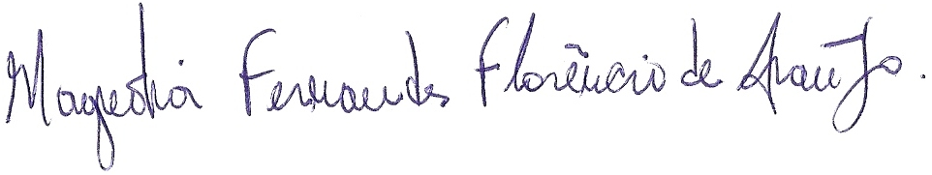
Magnólia Fernandes Florêncio de Araújo
Doutor in Science (Ecology and Natural Resurces) – corresponding author

*luisa_rn77@hotmail.com
** magffaraujo@gmail.com (corresponding author)
***luizsodreneto@mail.com
****alineamor@gmail.com

